FAZAIA BILQUIS COLLEGE OF EDUCATION FOR WOMEN
PAF NUR KHAN RAWALPINDI



Parallel and Distributed Programming (LAB)

Complex Tasks

Submitted to

Ms. Iffat

Submitted By
Javeria Fazal
F21-62

Task 01: Write a C# program using TCP socket programming that;
- Sends Temperature to the server (Ask user temperature unit)
- Convert Celsius to Fahrenheit and vice versa.
- Server will send the converted unit to the Client and Client will display the converted unit.
- Source Code Screenshot:

- Server side:
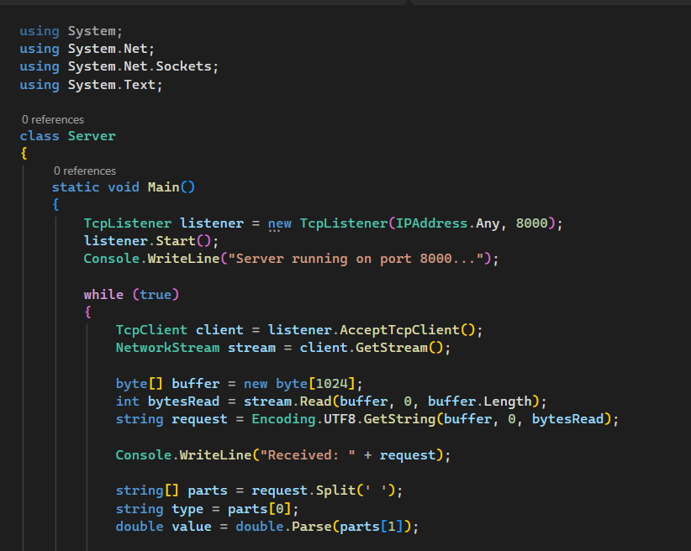
Figure 1: Server side
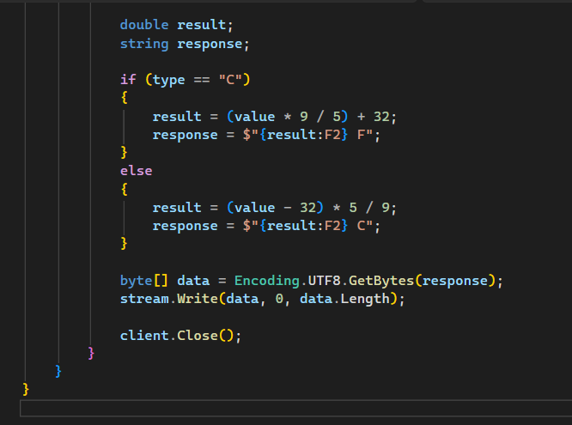
Figure 2: Server side (Cont.)
- Client side:

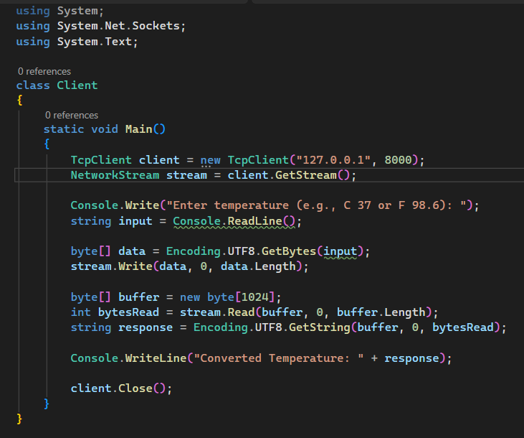
Figure 3: Client Side
- Output Screenshot:
- Client Side:

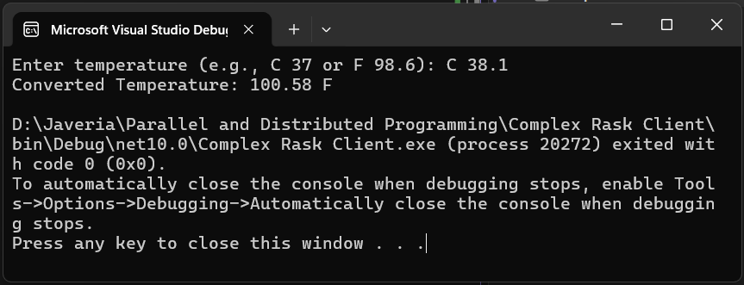
Figure 4: Output (Client)
- Server Side:
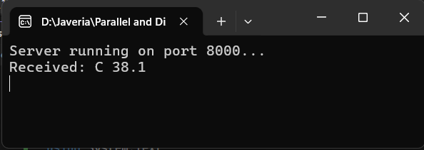
Figure 5: Output (Server)
Task 02: Write a C# program using TCP socket programming
- Client sends a sentence to the server and
- Server counts the number of words in the given sentence
- Client displays the number of words.

- Source Code Screenshot:
- Server Side:
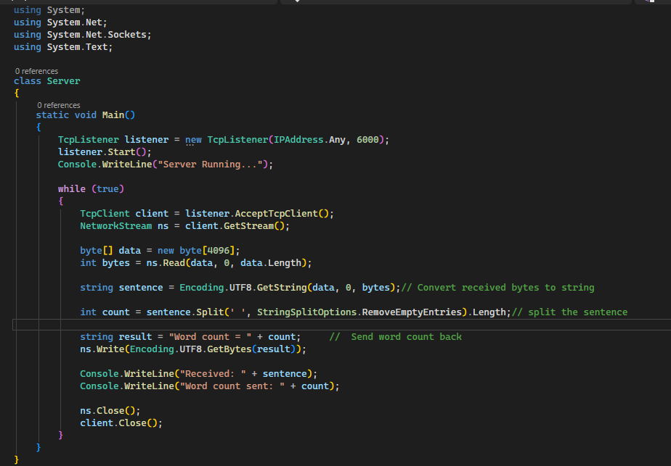
Figure 6: Server Side
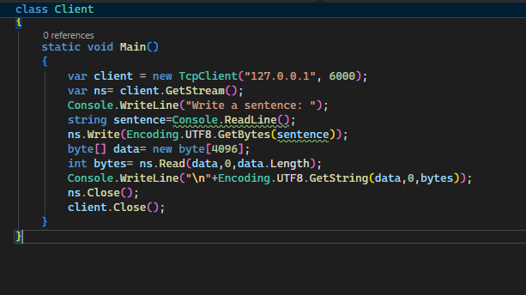
- Client Side:
Figure 7: Client Side
- Output Screenshot:
- Server side:
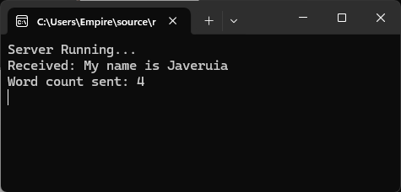
Figure 8: Server Output
- Client Side:

Figure 9: Client Output

